WILPSHIRE PARISH COUNCIL

CLERK: Lesley Lund Chair: Cllr Craig Ward
5 Hollowhead Close
Wilpshire
BB1 9LE

Email: wilpshireparishcouncil@gmail.com
Website: www.wilpshireparishcouncil.org.uk

Proceedings at a meeting held on 24 January 2024

Present:
Cllrs C Ward [Chair] A Gaffney [Vice Chair] J Foote D Briffet H Douglas A-M Keegan I Roberts

4900 | Chair’s welcome
4901 | Apologies for absence  Cllr G Munro and Clerk – Lesley Lund
4902 | Declarations of Interest  None
4903 | Public participation  None
 | DECISIONS
4904 | Approval of the minutes of the WPC meeting held on 13 December 2023  The minutes were approved as a true record  Proposed Cllr Foote and seconded Cllr A-M Keegan
4905 | Footpaths and Bridleway  a] 2 additional gates Parsonage and Ashes Farm – cattle field update now complete – and photos on the website – Cllr Gaffney  b] Stepping Stones – steps – agreed Clerk to send a letter to LCC re ownership of the steps  c] Path up to Golf Club from A666 & Hazels footpath stoning up council to receive a rough estimate of cost is £1117 for the stone and the putting the stone down – a proposal was made by Cllr Gaffney to instruct the contractor and this was seconded by  Cllr J Foote this was unanimously agreed  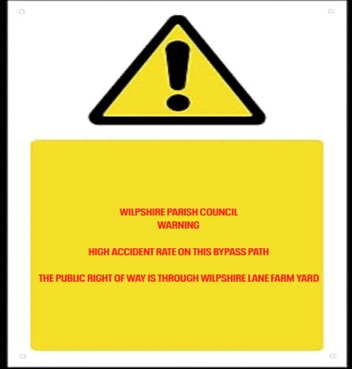  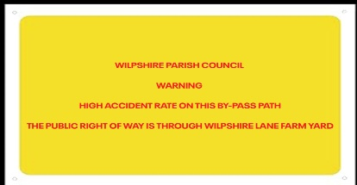  d] Bridleway – potential extra signage due to recent injuries and fall – rough prices for signs– land registry search revealed it was not registered land below Tippings Farm/Wilpshire Lane Farm  Examples of signs  It was agreed that 2 signs at Wilpshire Farm area to be acquired | Noted  Clerk  Cllr Gaffney
4906 | Updates and items arising from previous minutes  Min 4783/4771 Waste Bins - update -nothing at the time of the preparation of the agenda - noted
4907 | Items for the website
4908 | ACCOUNTS APPROVED FOR PAYMENT - Unanimous  L Lund January salary £522.64 – overpayment in December £25.74 – tax £104.60 = £392.30 cheque no. 102330  HMRC £104.60 cheque no. 102331  C Walton INV-4191 £395.02 - November visits cheque no.102332  D Briffett - land registry searches plans £12.00  Balances  Bank - £9784.91– subject to unpresented cheques[as at 22/12/2023]  Skipton BS – 30298.44
4909 | Planning Applications since the last meeting  3/2023/093 Clayton Manor Ribchester Road Clayton le Dale  Proposed construction of four one-bedroom apartments in a purpose-built detached building with separate dedicated access off Knowsley Road, following demolition of existing garage.  Planning Application - Ribble Valley Borough Council  WPC – No objections  3/2023/0982 Proposed extension to accommodate replacement garage, utility room and home office. At Braemar House Somerset Avenue Wilpshire  WPC - No objections  3/2024/0614 amendment to original application at Land to the East of Salesbury View  WPC – Clerk to enquire whether the original objections stand and also if the item is a delegated decision why?
4910 | Flooding/Blocked Drains Whalley Road  Cllr Roberts updated the Council on the current drainage problems on Whalley Road – it is believed that LCC are going to attend to this. | Next Agenda for progress
4911 | Durham Road Play Area - Meeting with Sovereign took place 12 January – A verbal update was given and Council agreed that 2 more companies should be contacted for quotations.  LEF Grant to be looked at when other quotations are in and agreement by Council is made to purchase. | Next Agenda for progress
4912 | Bio diversity grant - 3 nest sparrow box bought from RSPB. Cllr Briffett to reported there had been no response to rearrange the meeting. Clerk to re contact CANW | Clerk to contact CANW
4913 | PNFS – membership and grant  WPC are now a member of PNFS  Potential grant application for the stoning work at The Hazels etc and perhaps more gates for Wilpshire and local Jubilee Trail if the PNFS will pay for them. | Noted
4914 | Meetings attended by councillors  None
4915 | Network Rail – collapsed fencing behind Bryers Croft – Council was updated that a tree had been removed on the path behind Bryers Croft otherwise no action by Network Rail. | Noted
4916 | Items for the Newsletter  Footpaths  Gates 9/10  Slippy Path  Tree inspections/treatments  Daffodil planting on open spaces  Christmas trees  Flooding on Tippings path now sorted  £500 donated to the SAFE campaign  Contributed to defibrilator an paying for electricity supply  £500 from LCC for footpath grant  £300 Biodiversity Grant – Daffodils and bird boxes  Warning signs re Tippings Farm path  Liaising with police criminal issues  Public participation  Street signs cleaning | Nest Agenda – progress
4917 | Speeding Ribchester Road –  Min 4883 – Cllr Foote and Cllr Roberts updated the Council | Next Agenda
4918 | Consideration of Donations for 2023/2024 and separate donation for room hire during the financial year 2023/2024  To agree any donations for 23/24 Decision and vote required  Last years donations were as follows:  N W Ambulance £105.00  Little Green Bus £155.00  Samaritans Pay for a Day £85.00  Bowland Mountain Rescue £105.00  --------------------------------------------------------------------  To agree donation for room hire to Wilpshire Methodist Church  Last year £400.00 donation  Decision – it was unanimously agreed to round up donations given last year by £5 each and Wilpshire Methodist to be given £425.00 as a donation in respect of room hire. | Next Agenda
4919 | To approve current Risk Assessment  Deferred to the next meeting | Next Agenda
4920 | To approve the current Asset Register  Deferred to the next meeting | Next Agenda
4921 | To approve current insurance requirements  Insurers are BHIB premium paid May 2023 £750.42  Deferred to the next meeting | Next Agenda
4922 | Any other business
4923 | Next Meeting – 6 March 2024

