WILPSHIRE PARISH COUNCIL SPRING NEWSLETTER 2022

CHAIRMAN’S MESSAGE

The past twelve months continued to be challenging for the Parish Council. At least on-line meetings gave way to meetings in person and life for Wilpshire residents began to return to some sort of normality as the vaccination campaign accelerated and COVID restrictions were gradually eased.

The Parish Council continued to improve local amenities within its limited budget and, as always, remained a conduit for the community to express concerns and, occasionally, plaudits.

Numerous residents complimented the Parish Council on its work to improve the local public footpath network which has been ongoing for several years and continues. During the past year the Parish Council was successful in an application for grant funding from the Lancashire Environment Fund to provide three kissing gates on the well-used path leading from the golf course to Snodworth Farm. These replaced three awkward stiles on what is also the 396 mile long Lancashire Way. Work was also funded to improve the surfaces of the footpath leading from Hollowhead Lane to Hollowhead Avenue and, more recently, further surface work was done on the footpath leading from Whalley Road up to the golf course. As a result of the Parish Council’s funding, our local public footpath network has never been in a better state and this has encouraged greater use by locals and the wider community. Special thanks go to Councillor Tony Gaffney for his work in organising the grant application and contractor.

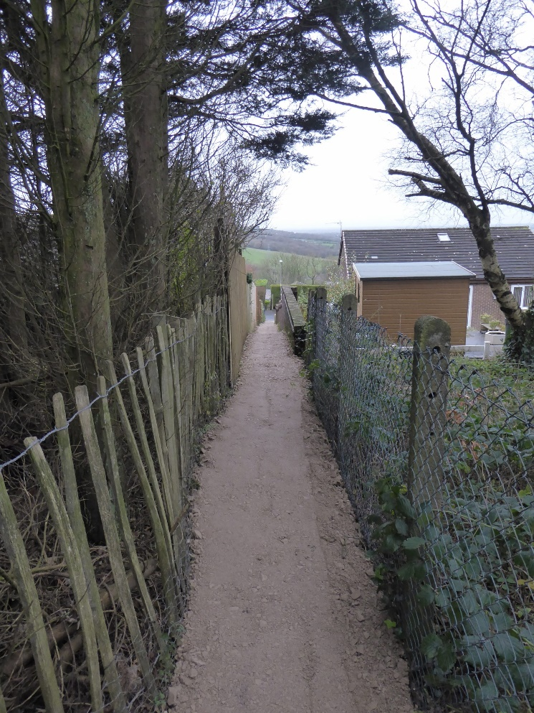

Surface improvement work on the footpath leading to Hollowhead Avenue

The arrival of spring in Wilpshire is heralded by the impressive display of daffodils along Whalley Road towards Langho. These were planted more than fifteen years ago and paid for by the Parish Council at the time. In the past year further bulbs were planted along this section to try to fill the gaps and additional bulbs were planted at other locations within Wilpshire. Likewise, summer bedding and additional bulb planting at the traffic light triangle and Ramsgreave & Wilpshire Station was undertaken to enhance the visual amenity of the area. As in previous years, the Parish Council provided Christmas trees for display outside local shops.

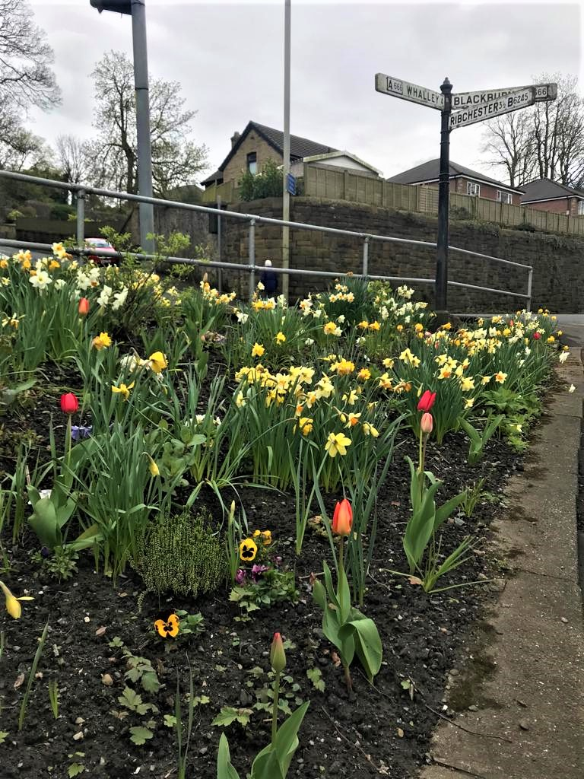

Spring display at the traffic lights’ triangle

The Parish Council maintains the Durham Road Play Area ensuring that it is safe and kept in good order. In the past year sections of the perimeter fence were replaced and a tree survey organised. Parish Councillors are currently discussing the provision of new equipment but this is a long term and expensive exercise and won’t happen immediately.

Parish Council meetings have a fifteen minute public participation session at the beginning and in these local residents can bring concerns and issues to the attention of councillors. Sometimes local issues need a wider and larger forum and the Parish Council can act to enable this. A good example of this was the recent public meeting organised to enable local residents to air concerns and listen to information given by local borough councillors and Lancashire county councillor relating to the application for a large housing development at Salesbury View off Whalley Road. This was a well-attended and well received initiative which helped residents understand the associated issues, implications and impact relating to the proposed development.

I should like to take this opportunity to thank my fellow councillors for their commitment and support in the ongoing work of the Parish Council. It was a somewhat unsettling year with five councillors resigning for different reasons – Councillors Jean Bremner, Gary Shulman, Dave Coleman, Catherine Cotton Ambler and Tim Westwell. I thank them for their work with us. During the past year we welcomed a new councillor – Malcolm Edwards and more recently we welcomed Anne Keegan and Peter Burrows to the Council. Since his appointment, Malcolm has been active with the issue of traffic on Knowsley Road – see separate article.

The Parish Council is well served by our Clerk, Lesley Lund and I thank her for her help and support in the administration of our affairs. We employ Chris Walton as Parish Lengthsman and he has worked diligently to maintain the appearance of the local area. Of course, the Parish Council can only do so much and often it is the effort put in by the local residents themselves to keep the area looking tidy and attractive or, for example, keeping an eye on elderly neighbours or being vigilant in ensuring possible crime is reported which helps to make Wilpshire a pleasant place in which to live.

KNOWSLEY ROAD

Whilst the Parish has many residential streets that are subject to 20mph zones, Knowsley Road is the only one that provides a “short cut”.

Why are 20mph zones so important? Put simply it is down to stopping distances, the Highway Code states that the stopping distance at 20mph is three car lengths, at 30mph this doubles to six! Therefore, many residential roads, where vulnerable road users - children, pedestrians and cyclists being the most at risk from fast moving vehicles - have had their speed limits reduced.

After the speed cushions were installed on Knowsley Road LCC Highways conducted a Speed Survey that appeared to show that they were working. However, on closer inspection it was found out by the Parish Council that this was conducted at the “pinch point” where the road narrows to single file under the railway bridge.

At the request of the Parish another survey was conducted in January of this year, between the entrances to Brooklyn Road and Woodcrest. Sadly, the data from this study showed a very different result, with an average speed of 30mph being recorded in both directions a peak two and a half times the posted limit.

We are liaising with our local PCSO Caroline Pemberton and our County Councillor Alan Schofield, to look at ways of getting the message to slow down across to users of the road. Hopefully, if the average speed is lowered the benefit of using the route as a “rat run”, to avoid the Wilpshire Hotel traffic lights, will be reduce. From this we will see the double benefit of less traffic, moving at a slower speed, leading to a safer environment for us to live in, which will encourage more residents to walk and cycle in safety.

LOCAL SHOPS AND BUSINESSES

The following is a list of shops and businesses with premises open to the public.

Guys n Dolls, 5 Ribchester Road BB1 9JH

The following is a list of shops and businesses with premises open to the public.

Vicky offers a personal service in all aspects of hairstyling.

Tel. 01254 248143 @guysn[dollshairsalonblackburn](https://www.facebook.com/pg/guysndollshairsalonblackburn/reviews/?referrer=page_recommendations_see_all&ref=page_internal)

Deephaus Sarah Newton Designs 9 Whalley Road BB1 9LQ

Interior and exterior design service. Specialist in Kitchen, Bedroom and Bathroom design. Sarah offers either a design only service or a full service package, which includes design, project management and installation.

Tel 01254 243841 [www.deephaus.co.uk](http://www.deephaus.co.uk)

Beech’s Butchers, 11 Whalley Road, BB1 9LQ

Local butchers, distributors of meat, poultry and vegetables.  A wide range of new dishes, ready meals and home-made pies is also available.

Tel. 01254 246612 [www.beechs.co.uk](http://www.beechs.co.uk)

Right at Home, 15 Whalley Road, BB1 9LQ

Domiciliary care in the comfort of your own home.

All levels of support from personal care and assistance with day to day tasks, through to complex conditions and care needs. A 24/7 live in service is also available.

Tel. [01254](http://www.rightathomeuk.com/) 658899 office hours 24/7 out of hours mobile: 07715446095

Email: [Julie.foote@rightathomeuk.com](mailto:Julie.foote@rightathomeuk.com) [www.rightathomeeastlancs.com](http://www.rightathomeeastlancs.com)

Post Offices: The nearest counters are at Spar, Portland Road, Langho and Whalley New Road, Roe Lee

Wilpshire Hotel, Whalley Rd Tel. 01254 248415

DATES OF FUTURE PARISH COUNCIL MEETINGS:

11/05/2022 Annual Parish Council Meeting

22/06/2022

01/08/2022

16/09/2022

26/10/2022

7/12/2022

18/01/2023

08/03/2023